

Cross Words

Monthly Newsletter of Cross Ev. Lutheran Church

October 2012 Volume 12, Issue 10

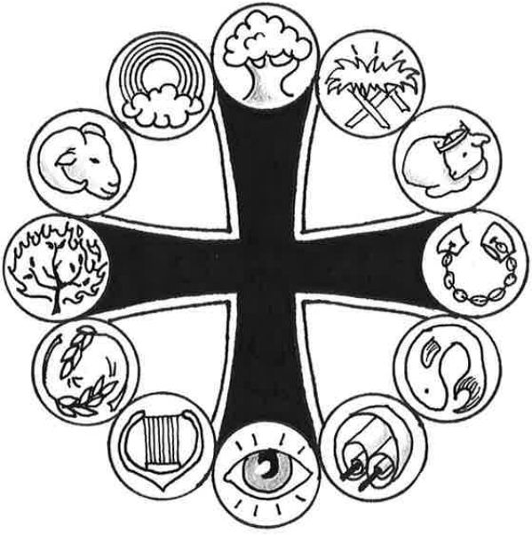

**Prominent People of the Bible**

***Paul***

*“Christ Jesus came into the world to save sinners—of whom I am the worst. But for that very reason I was shown mercy so that in me, the worst of sinners, Christ Jesus might display his unlimited patience as an example for those who would believe on him and receive eternal life.” (1 Timothy 1:15-16)*

“What chance do I have of getting to heaven?”

“How could God love someone like me?”

“What I’ve done in my life is too big…too bad…too horrible for Jesus to forgive.”

How easy it is to beat ourselves up with thoughts of despair like these! The apostle Paul understood these feelings. The man who ended his life as one of the greatest Christian missionaries did not start out that way. Opposed to Christ in his early life, he tried desperately to stop Christianity from growing. He described himself at that time as a “blasphemer and a persecutor and a violent man” (1 Timothy 1:13). Can you imagine standing before God and admitting that you did everything possible to stop the growth of his kingdom, including killing those who believed and preached in Jesus’ name? If we would deem anyone unworthy of being part of God’s kingdom, it would be Paul.

However, Paul’s story culminates in God’s grace, his undeserved love. Paul himself set the amazing truth of God before us: “Christ Jesus came into the world to save sinners—of whom I am the worst.” Jesus came into this world to forgive and save even this violent, blaspheming persecutor. Why did God do this? First, because he loved Paul and wanted Paul to live with him eternally in heaven. But God also did this to give us an example of the depth of his love for all people. In demonstrating his patient love to Paul, God wants us to be confident that no matter what we’ve done, all of our sin is fully and freely forgiven in Jesus our Savior.

Jesus came into this world to save sinners—not just some sinners, but all sinners—and that’s exactly what he did with his life, death and resurrection. Like Paul, God wants us in his family. He wants us to know his love and to live eternally with him in heaven. We can put to rest our thoughts and feelings about all the things we do and say and think that offend God. In Jesus, all our sins have been forgiven and removed from God’s sight forever. God’s amazing love is for sinners—like you and me!

**Graphic for Paul: *Shackles***

Paul endured imprisonment for the sake of the gospel message which he proclaimed.

**More information is located on line at WhatAboutJesus.com. Look for the *What About … Prominent People* link.**

**Important Questions –**

**Important Answers**

# What good is God?

# All he does is make rules, right?

It’s easy to think that all God does is make rules. We learned all about the Ten Commandments when we were kids. We learned a little bit about authority too. How often did our mothers say, “Wait until your father gets home”? When our dads did come home, we got it—some form of punishment—a spanking, loss of privileges, a trip to our rooms, a tongue lashing. We learned to obey or else.

But we also learned that if we did certain things, we could earn rewards. If we ate all our lima beans, we could watch television. If we worked in the yard, we could earn a little extra money or a few more privileges. These are simple principles—and important ones. Without the principles of punishment and reward, our society would not sentence criminals to prison or honor those who contribute great things to our world.

We’re used to working hard to earn our pay or achieve some success. Yet God chose not to work that way. He knew that we could never do enough to earn his love and forgiveness. Imagine what we would have to do to make God love us. It’s impossible. God’s rules demand perfect obedience. Can you remember a day when you didn’t get angry or complain? How about a day when you didn’t think a bad thought? Or a day you didn’t abuse the name of God and his Son, Jesus Christ? You see, we might be able to earn a promotion by our hard work, but we can’t do enough to earn what only God can give—forgiveness and eternal life.

In spite of that, God loves us anyway. He loves us more than we could ever deserve. He washed away all our faults and failures with the blood of his Son, Jesus. His love is a free gift to every man, woman, and child on earth. That’s why the angels sang when Jesus was born.

But many people don’t want God’s gift. They decide to work to earn his love. Hardworking men and women think that they can work to earn heaven too. But they can’t. If they don’t want God’s gift, God will give them what they work for—a good job, a nice home, a happy retirement. But because they can’t do enough to earn heaven, they won’t go to heaven or receive God’s forgiveness. It’s as simple as that.

And God’s rules? God gave them to us so we would know how to show him our gratitude for his gift.

**C:\Users\church office\AppData\Local\Microsoft\Windows\Temporary Internet Files\Content.IE5\QDEIEE37\MC900383922[1].wmfBIBLE STUDY OPPORTUNITIES**

If you are not attending at least one of our Bible Studies, it’s never too late to start!

***Sunday Morning Bible Study*** begins at 10:15 am. We meet in the basement fellow-ship hall. Coffee, juice and goodies are served.

We are currently doing a study called ***Families of the Bible,*** looking at some biblical families and seeing what they can teach us concerning issues that face families today.

***Walnut Bible Study*** meets on Mondays, at 9:30 am. The ***End Times –*** *Jesus is Coming Soon* is our subject, as we look at what the Bible teaches and does not teach about this sometimes confusing and frightening subject.

**Men’s Breakfast Bible Study**

MBBS for October will meet on Saturday, Oct 20 at 9:00 am. The breakfast menu will pancakes.

We will continue our study – ***How Can They Teach That?*** *(And Still Claim to Believe The Bible).* This study looks at how some church bodies adopt doctrinal positions so obviously contrary to Scripture, for example, concerning creation, women in the ministry, homosexuality and life issues. This is a good opportunity to review what the Bible teaches on these subjects, and how some twist or ignore what God’s Word says.



**CROSS LIGHTS** will meet on Tuesday, Oct 2 at 7:30 pm., We will continue the study, *Bad Girls of the Bible.*

*Cross was featured in the Minnesota District Women’s Ministry Newsletter in the September edition. Check it out at MN District WELS Women's Ministries [mnwelswomen=gmail.com@mail123.us2.mcsv.net]*

**C:\Users\church office\AppData\Local\Microsoft\Windows\Temporary Internet Files\Content.IE5\XCG8FXOE\MM900336678[1].gif**

**The BANNER COMMITTEE will meet on Mondays, Oct 8th & 22nd at 7:00 pm.**

**Senior Fellowship – 10/25**

We will meet on Thursday at noon.

Watch the bulletin for Details

**NEWS FROM WEST LUTHERAN HIGH SCHOOL**

**SPAGHETTI SUPPER CONCERT at WEST:** "Show Tunes" is the theme of this year’s Spaghetti Supper Concert at West.  The concert will be held on Tuesday, October 16th at 7:30 PM, preconcert music prior.  Spaghetti will be served from 6-7:30 PM.  This concert will feature music from many famous Broadway Shows:  *Phantom, Cats, and Joseph*, just to name a few.  *A free-will offering will be taken to support the music department and will be supplemented by Thrivent Financial for Lutherans.*

**WEST to HOST CHORAL FESTIVAL:**  West has the unique privilege to HOST this fall’s West Regional Choral Festival.  November 16-18, around two hundred singers from nine different WELS high schools across the country will gather at West to perform two concerts.  The theme of the festival is “Praise the Lord for His Mighty Works”.  Mark your calendars now for these special concerts.  POPS Concert – Friday, November 16, 7 PM.  Sacred Concert – Sunday, November 18, 2:30 PM.

**VETERAN'S DAY** West Lutheran High School will be celebrating veteran's day on Friday, November 9, 2012.  We would love to invite any veterans (or active service members) that you know - family members, friends, neighbors, etc.  The day will begin at 8:45am with a continental breakfast, followed by chapel and a Veteran's Day program.  If you are a veteran or  know of anyone that you would like to be included, please email their name and address to us so that we may send them an invitation.

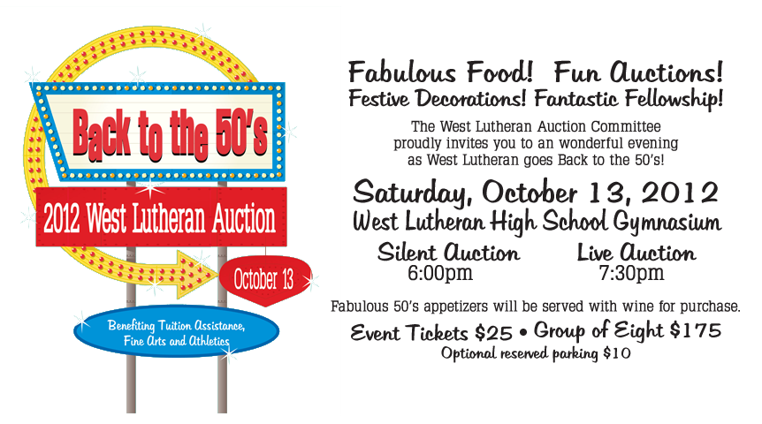

**MEMORIAL** Some new chairs for the church basement have been given in memory of Jim Taylor by the Taylor family. Our thanks to them.

**CONGREGATIONAL MEETING**

The October congregational meeting will take place on Sunday, Oct 28 at 10:15 am (following the Sunday morning worship. All are encouraged to attend.

From: Cross LIGHTS

Re: Funeral Committee

At our September 6th meeting we discussed the future of the funeral committee. Due to limited participation in Cross LIGHTS, it has become necessary to draw from our total congregation membership to carry out the responsibilities of the funeral committee. At our meeting we came up with the following suggestions:

* Form “funeral committee groups” . Four groups was suggested - Group A, B, C & D. Have 1 “lead person” to head each group and ideally 10 persons in each group. Group “A” would work at the 1st funeral (beginning in January) and group “B” at the second funeral, etc. It was also suggested that if needed, the lead person from the preceding group could help the next group. Responsibilities of the lead person would be:

- be contact person for the family to discuss what they would like to serve

- call other ladies in her group to help

-purchase whatever food the family decides on

-keep up notes on each funeral

- if a check is given to the church for serving the funeral, see that it gets to the treasure

r-give food bill to funeral home representative

-take care of “leftovers” and give to family

-make sure kitchen is left clean and orderly

-arrange to have dishtowels and dish cloths washed and returned to church

* Send out a questionnaire to all members of the congregation asking in what capacity they would be able to serve.

- on questionnaire ask if person would be available weekdays or on a Saturday or Sunday to help to enable those who work fulltime to help.

- kitchen help that would set up, do prep work and serve the lunch and clean up afterwards.

-donate a cake or bars, etc. if called upon

* We also propose that the funeral committee would only purchase ham and buns and make up the ham sandwiches, prepare coffee and Kool Aid and ask for donations of bars or cakes. It would be the family’s responsibility to order and bring additional food if they so desire. We will provide a list of caterers for their use if needed. We would continue to serve the lunch. With the high cost of groceries, this would enable the family to shop at discount grocery stores and obtain better prices.
* Does the church want to supply paper products for funerals?

It is a blessing to be able to provide this service to the families at this difficult time and we need to keep this in mind. We pray for God’s guidance in this matter.

